**File Based Session in Django 5**

For file-based sessions, we need to go into mainproject/settings.py and add code that changes the default database storage into file-based storage.

SESSION_ENGINE= 'django.contrib.sessions.backends.file' # Change SESSION_ENGINE in the settings as file, because by default it is set to the database.

SESSION_FILE_PATH = BASE_DIR / 'session'    # Here is the directory where we save the file.

Don’t run makemigrations and migrate folder

And make folder name session:

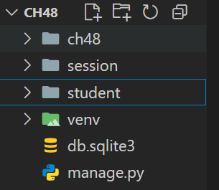

Here is student/views.py:

from django.shortcuts import render

def setsession(request):

 request.session['fname'] = 'Sonam'

 request.session['lname'] = 'Kumari'

 return render(request, 'student/setsession.html')

def getsession(request):

 first_name = request.session.get('fname')

 last_name = request.session.get('lname')

 return render(request, 'student/getsession.html', {'first_name':first_name, 'last_name':last_name})

def sessionclear(request):

  request.session.flush()

  request.session.clear_expired()

  return render(request, 'student/sessionclear.html')

And than simple run the project

Python manage.py runserver

Now when we hit the set command than we hit the get and we can see that the session data is stored insde the file of session folder and that file name same as session id

Complete code:

Views.py:

from django.shortcuts import render

def setsession(request):

 request.session['fname'] = 'Sonam'

 request.session['lname'] = 'Kumari'

 return render(request, 'student/setsession.html')

def getsession(request):

 first_name = request.session.get('fname')

 last_name = request.session.get('lname')

 return render(request, 'student/getsession.html', {'first_name':first_name, 'last_name':last_name})

def sessionclear(request):

  request.session.flush()

  request.session.clear_expired()

  return render(request, 'student/sessionclear.html')